CSC 2400-041
Summer 2025
Homework 2 Key

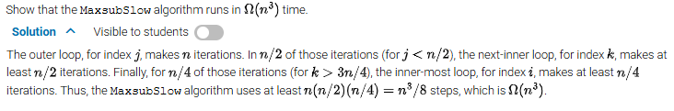


10 n log n < n √n ; since n>0 we can divide both sides by n (cancel common factor n)
10 log n < √n ; let’s assume log n =log₂ n
We try a few values
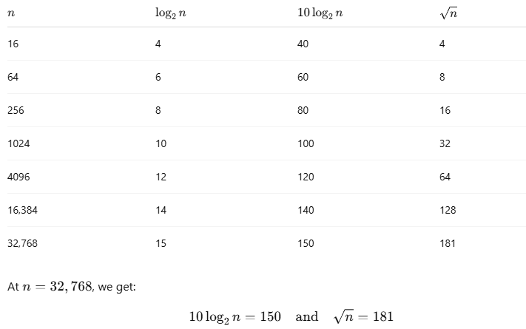
So, for all n>n₀=32,768, algorithm A is faster than B.
Solutions ok for considering log n as log ₁₀ n

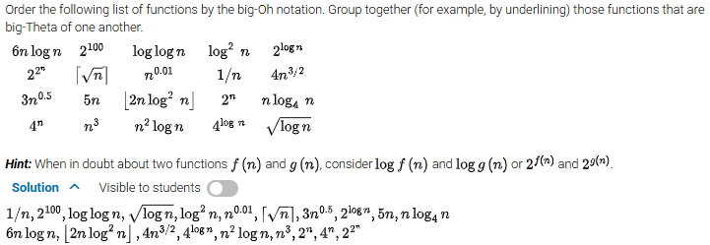

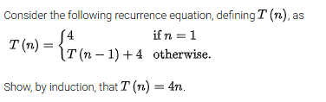
Both induction or backward substitution methods carry credit.
Proof by induction:
Base case: n = 1
T(1)=4 by definition, also 4n= 4(1) = 4 The base case holds
Inductive step: assume for an arbitrary k, K>1, T(k) = 4k. We want to prove that T(k+1)=4(k+1).

T(K+1) = T(k) + 4
T(k) = 4k by our inductive hypothesis
Then T(k+1) = 4K + 4 = 4(k+1)
By the principle of Mathematical induction, we proved that T(n) = 4n for all n>1

Proof by backward substitution:
T(n)=T(n-2)+4+4= T(n-2)+2*4
T(n)=T(n-3)+4+2*4= T(n-3)+3*4
For an arbitrary 1<=i<=n-1
T(n)=T(n-i) + i*4
We will choose I such that n-i=1 from the initial condition T(1)=4; i=n-1
T(n)=T(1)+(n-1)*4=4+4(n-1)=4n

- A quadratic algorithm with processing time T(n) = cn² spends T(N) seconds for processing N data items. How much time will be spent for processing n=5000 data items, assuming that N = 100 and T(N) = 1ms?
Let’s find c from T(N) = cN² -> c = T(N)/N² = 1 / 10,000 ms
N=100
T(N)=1 ms

Let’s now calculate T(n) for n = 5,000
T(n) = c n² = 1/10,000 ms * 25,000,000 = 2,500 ms = 2.5 s
OR (different solution) T(c*N) for a quadratic function is c² T(N).
Here, c=5,000/100=50, T(c*N)=50 *T(N)=2,500*T(N)=2,500ms = 2.5 s
,
- Use the informal definitions of big-oh, big-theta, and big-omega to determine whether the following assertions are true or false.
Assertion TRUE / FALSE
n(n+1)/2 ϵ O(n³) True
n(n+1)/2 ϵ O(n²) True
n(n+1)/2 ϵ Θ(n³) False
n(n+1)/2 ϵ Ω(n) True

- Let t(n)= 9𝑥² − 17𝑥⁶ + 15√𝑥 and g(n)= 3𝑥⁷ + 1000𝑥⁵ + log₂ 𝑥.
a.


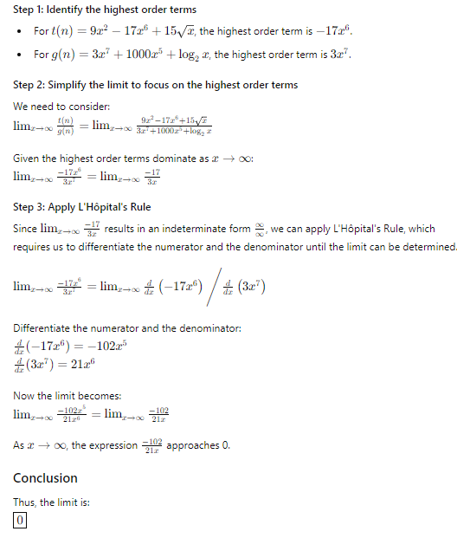

b. Based on your answer to part (a) above, is t(n) ϵ O(g(n))?
Yes
c. Based on your answer to part (a) above, is t(n) ϵ Ω(g(n))?
No
d. Based on your answer to part (a) above, is t(n) ϵ Θ(g(n))?
No

For b and c credit will be given if your a) is incorrect, but b) and c) are correct based on your answer in a)

- Let t(n) = nlog₂(n) and g(n) = n².



No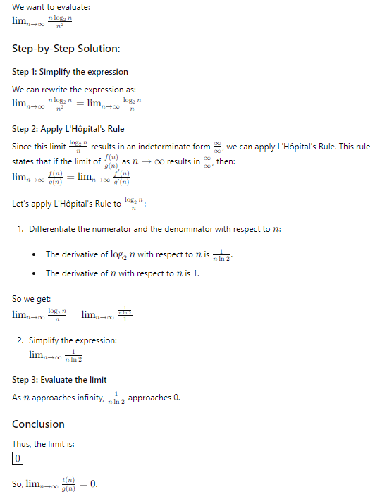
- Based on your answer to part (a) above, is t(n) ϵ O(g(n))? Yes
- Based on your answer to part (a) above, is t(n) ϵ Ω(g(n))? No
- Based on your answer to part (a) above, is t(n) ϵ Θ(g(n))? No

- Find the order of growth of the following sums. Use the Θ(g(n)) notation with the simplest function g(n) possible.
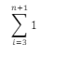
= (n+1)-3+1 = n-1
- Find the order of growth of the following sums. Use the Θ(g(n)) notation with the simplest function g(n) possible.
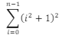
(i² + 1)² = i⁴ + 2i² + 1
$\sum_{i=0}^{n-1}{(i^2+1)^2}$ = $\sum_{i=0}^{n-1}{i^4}$ + $2\sum_{i=0}^{n-1}{i^2}$+$\sum_{i=0}^{n-1}{1}$
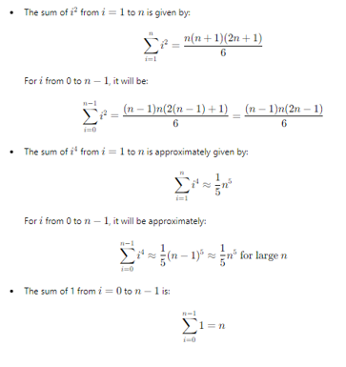

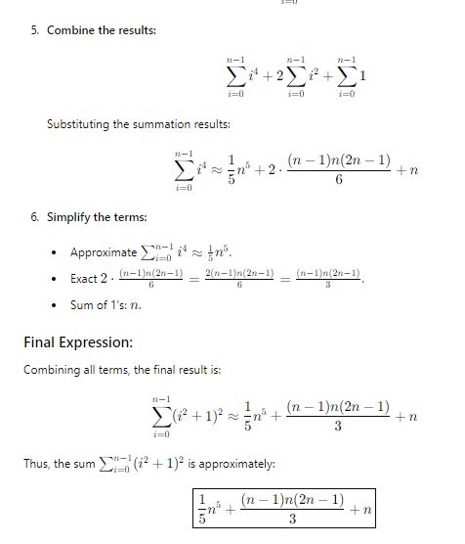

- Solve the following recurrence relation using backward substitution:
x(n) = x(n−1) + 5 for n>1, x(1) = 0
x(n) = x(n-2) + 5 + 5 = x(n-2) + 2* 5
= x(n-3) + 5 + 5 + 5 = x(n-3) + 3*5
.
.
= x(n-i) + i*5, for an arbitrary i>1
Using the initial condition we choose i such that n-i=1, i=n-1
X(n) = x(1) + (n-1)*5 = 0 + 5(n-1) = 5(n-1)

- Consider the following recursive algorithm:
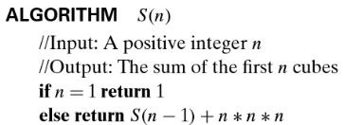
Set up a recurrence relation for this function’s values and solve it to determine what this algorithm computes.
S(n) = S(n-1) + n³, initial condition S(1)=1
= S(n-2) + (n-1)³ + n³
= S(n-3) + (n-2)³ + (n-1)³ + n³
.
.
= S(n-k) + (n-k+1)³ + (n-k)³ + …+(n-1)³ + n³, for an arbitrary k > 1
Using the initial condition, we choose k such that n-k=1, that is k=n-1
S(n) = 1 + 2³ + 3³ +…+(n-1)³ + n³, the sum of the first n cubes
= (n(n+1)/2)²

